Ooyala Backlot SharePoint Plugin Development
Functional Specification Document

Version: 0.3
Date: 23-July-2012

Submitted to:
Ooyala Backlot

By:
CSS Corp Pvt Ltd
3031 Tisch Way, Ste 1002, San Jose, CA 95128
Tel: 408-615-5700 Fax: 408-615-5707
URL: http://www.csscorp.com

Revision History
Version | Date | Revision Notes | Author(s)
0.1 | 25-June-2012 | Initial draft | Venkat
0.2 | 23-July-2012 | Review comments implemented | Venkat, Velmurugan
0.3 | 23-July-2012 | Review comments implemented | Karlmarx

Table of Contents

Table of Contents 3
Table of Contents 3
Objective 5
Objective 5
Requirements Overview 5
Requirements Overview 5
Solution Architecture 6
Solution Architecture 6
Application Requirements 6
Application Requirements 6
Install SharePoint Plug-in 6
Install SharePoint Plug-in 6
Edit API Settings 7
Edit API Settings 7
Taxonomy 7
Taxonomy 7
1.1.1 New label 7
1.1.2 Edit label 8
1.1.3 Delete label 8
Media Library with Details View 8
Media Library with Details View 8
1.1.4 Show Media Library details view with search facility 9
1.1.5 Show Media Library details view with pagination 9
1.1.6 Show Custom Metadata 9
1.1.7 Show Labels 10
1.1.8 Allow Edit 10
1.1.9 Allow Delete 10
Media Library with thumbnail view 11
Media Library with thumbnail view 11
1.1.10 Show Media Library Thumbnail View with Pagination 11
1.1.11 Show Media Library Thumbnail View with Search facility 11
Media Player 12
Media Player 12
Media Player Settings 12
Media Player Settings 12
1.1.12 Creating New Player 12
1.1.13 Edit Player 13
1.1.14 Delete Player 13
Media Upload From Local Computer 13
Media Upload From Local Computer 13
1.1.15 Upload Contents from Local Computer to Ooyala 13
1.1.16 Associating an Asset with a Label 14
1.1.17 Associating an Asset with a custom Meta data 15
Media Upload From Share Point Library 15
Media Upload From Share Point Library 15
1.1.18 Upload Contents from share point library to Ooyala 15
1.1.19 Associating an Asset with a Label 15
1.1.20 Associating an Asset with a custom Meta data 16

Objective
Objective of this document is to capture CSS’s initial understanding about the high level requirement, training given by Ooyala. This document will serve as input to the further phases of the project.

Requirements Overview
Ooyala offers a modular, full-featured video solution. A brand new content type AUDIO, VIDEO can now be uploaded and managed directly in Backlot. The below describes the generic functionality of SharePoint plugin. The entire system is broken down in to below distinct features.

- Plugin Authentication at Installation – The plug-in will be installed on the SharePoint server and related link would be available to the users when they logon to SharePoint. Link availability to user requires SharePoint Administrator to provide appropriate access privileges. SharePoint Plugin accepts User Credentials like Partner Code, Secret Code and API Key while Installing the Plugin in SharePoint. Application will validate User Credentials with Backlot API using API Validator. If the provided Partner Code, Secret Code and API Key are valid, it will save API info in Database. If provided Info is not valid, it will throw exception. Whenever the user accesses the plug-in web part pages, the plug-in will internally authenticate the user against Ooyala Backlot using the saved credentials.

- Internal Authentication at Loading in each Web Parts - Plug-in will provide an Option as link in Share Point Site for Web Parts. Whenever Web Part is created or loaded or added to Share Point Web Part Page, Authentication will be done internally. If Authentication is valid, it will show relevant web parts. If Authentication is not valid; it will throw exception and redirect the Configuration Page for setting up new API Info.

- Media Library – It is a document library in SharePoint where we upload media files. Media Library is consisting of a row and column view of the assets. It has two views as Details View and Thumbnail View. Here we can edit, delete assets. Edit Assets will support applying Standard Metadata, Label Taxonomy and Custom Metadata to Media Assets. Delete Asset option will permanently delete media asset from Backlot Application.

- Media Uploader - Upload Dialog facilitates with two options as Local Files to Backlot Application and Share Point Media Library to Backlot Application. While uploading new asset, user can apply standard metadata, labels, custom metadata. And user can select Pending Approval or Live as Post Upload Asset Status. Based on the user selection, it will be either Paused or Live and it can be changed by Backlot User in Backlot Application.

- Media Search - To provide Unicode search by Title, Description, Label and status in Media Library Views (Detail View and Thumbnail View).

- Media Player – To play, pause, stop and seeking forward the media files. It provides option to select Media Asset and Media Player.

- Player Settings - To add or remove new embedded player. It provides options to set Player properties like Ooyala branding, Start Screen options and End screen Options. For example, Share, Digg, Facebook, Email, Twitter, Info, Title, Description, Presented by, Show Share URL, Replay, Embed, Channels, Ad Countdown Message, Volume, Bitrates, Buffer on Pause and Always show scrubber bar.

Backlot’s Label Taxonomy and Custom Metadata - Taxonomy is about organizing asset by attaching descriptive terms as a label, these terms might describe what asset belongs to a particular group. Custom metadata enables to add useful information to your assets. User can associate custom metadata with videos, Custom meta data useful for purpose of Organizing and categorizing content, Storing information about videos to display on pages on which they are embedded, Specifying information about how to display videos

Solution Architecture
The following diagram shows the high level solution architecture indicating the relationship between the different aspects of the overall system.

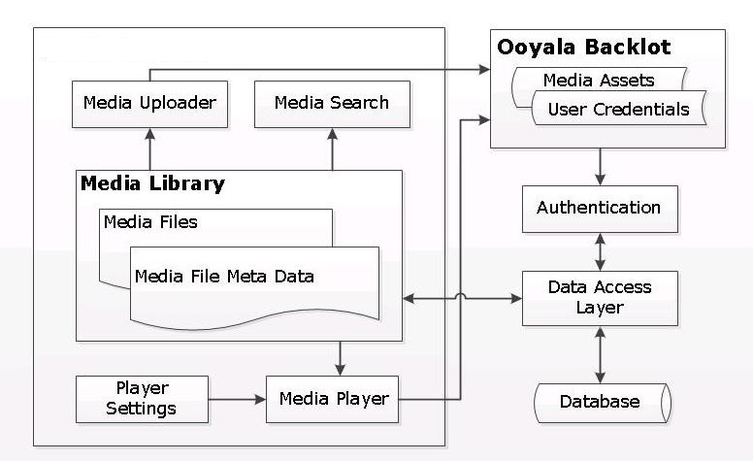
Application Requirements
Install SharePoint Plug-in
Download Plugin Zip File from Backlot Site to install Plug-in in SharePoint. Plug-in will be installed on the SharePoint server and related link would be available to the users when they logon to SharePoint. Link availability to users might require SharePoint Administrator to provide appropriate access privileges. Accept the Ooyala Backlot credentials like Partner Code, Secret Code and API Key at the time of installation from the user. After successful authentication, Ooyala Backlot credentials will be stored in Share Point database for the future interactions, whenever the user accesses the web part page; the plug-in will internally authenticate the user against Ooyala Backlot using the above credentials.

Edit API Settings
Click on API Settings Web Part Page for editing User Credentials like Partner Code, Secret Code and API Key. Given User Credentials will be validated using API Validator through Backlot API. After Successful Validation, given new API Info will be saved in Share Point Database for future internal Validations. After Failed Validation, Plugin will raise error message and API Info fields will be cleared in Configuration Page to collect new API credentials.

Taxonomy
Taxonomy is about organizing asset by attaching descriptive terms as a label, these terms might describe what asset belongs to a particular group

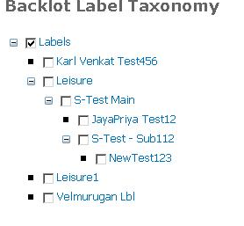

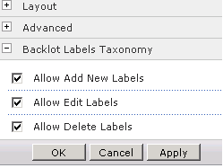

New label
Labels are useful for organize video library, searching for videos.
Create a new label:
- Login to SharePoint Application using SharePoint user
- Click on Label Taxonomy Link available in SharePoint Plugin
- Click on Edit web part link to select Allow Add New Labels
- Check on parent label checkbox to create a new label in parent hierarchy and Click “Add Icon”
- Check on associated checkbox to create a new label in child hierarchy

Edit label
Update Existing Label:
- Login to SharePoint Application using SharePoint user
- Click on Label Taxonomy Link available in SharePoint Plugin
- Click on Edit web part link to select Allow Edit Labels
- Check the label check box which needs to be edited
- Click on the Edit Icon on the top of the tree view hierarchy
- The label text appears in textbox on the bottom of the tree view hierarchy
- Input the revised text click on Tick icon

Delete label
To delete a particular label:
- Login to SharePoint Application using SharePoint user
- Click on Label Taxonomy Link available in SharePoint Plugin
- Click on Edit web part link to select Allow Delete Labels
- Check the label check box which needs to be deleted
- Click on the Delete icon on the top of the tree view hierarchy
- User receives a confirmation prompt to delete
- Click the yes to delete the label permanently from Backlot Application

Media Library with Details View

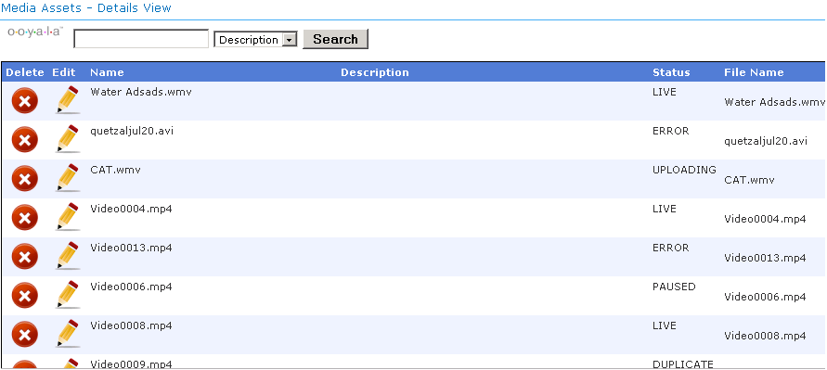

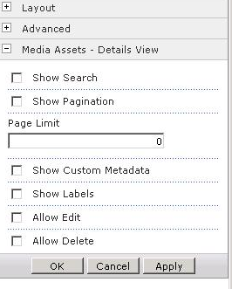

Show Media Library details view with search facility
- Login to SharePoint Application using SharePoint user.
- Click on Details View Link available in SharePoint Plug-In
- Click on Edit web part link to select show search option
- Search criteria appears on top of the Media Library Details View
- Media Library facilitates search criteria by Name, Description, Label, and Status.
- Enter the search criteria in textbox select one of the items in drop down list click on search button, search results will be displayed in list view on grid.

Show Media Library details view with pagination
- Login to SharePoint Application using SharePoint user.
- Click on Details View Link available in SharePoint Plug-In
- Click on Edit web part link to select Show Pagination
- Pagination appears on bottom of the Media Library Details View
- Media Library grid will display all available media files.
- By default grid displays 10 records per page, click on next button to see the next 10 records. Page Size can be changed and it is configurable in Edit Mode.
- Click on Previous button to view the previous set of records.

Show Custom Metadata
- Login to SharePoint Application using SharePoint user.
- Click on Details View Link available in SharePoint Plug-In
- Click on Edit web part link to select Show Custom meta data
- For Applying Standard and Custom Metadata, user needs to Click Edit Icon in the Details View Grid Row and Custom Metadata grid will be displayed in Edit mode.
- For each metadata entry, enter a Name and Value.
- Click on Tick icon to update in Backlot Application

Show Labels
- Login to SharePoint Application using SharePoint user.
- Click on Details View Link available in SharePoint Plug-In
- Click on Edit web part link to select Show Labels
- For Applying Labels, user needs to Click Edit Icon in the Details View Grid Row and Labels Tree view be displayed in Edit mode.
- User able to select multiple labels (checkbox) which are associated with asset.
- Click on Tick icon to update in Backlot Application.

Allow Edit
- Login to SharePoint Application using SharePoint user.
- Click on Details View Link available in SharePoint Plug-In
- Click on Edit web part link to select Allow Edit
- Edit icon appears on right of the media library details view
- Click on Edit icon to edit the title, description, labels, metadata of the assets.
- Click on Tick icon to save the asset properties in Backlot Application.

Allow Delete
- Login to SharePoint Application using SharePoint user.
- Click on Details View Link available in SharePoint Plug-In
- Click on Edit web part link to select Allow Delete
- Delete icon appears on right of the media library details view
- Click on delete icon to delete the asset

The search text box will have the default value as “Enter Meta Key” “Enter Search Text”, the search button will understand that 'No conditions' for search the asset. So it will return all the assets.
Note:
1) Share point Plug-In search will work as like “Ooyala API Scarch pad”.
- It take some times to get the search result for recent modified custom meta data for both Details view and thumbnail view.
Custom Meta Search : It will help to search the custom metadata's key and value
1) Select the “Custom Meta data” from drop down list.
2) It will open up two text boxes. Enter the meta data key text on purple on text box and enter the “Value” on Green color text box.
3) Metadata key text box should not be empty when Search text box have the text.
Search text can be empty or value when meta data key text box have the value.
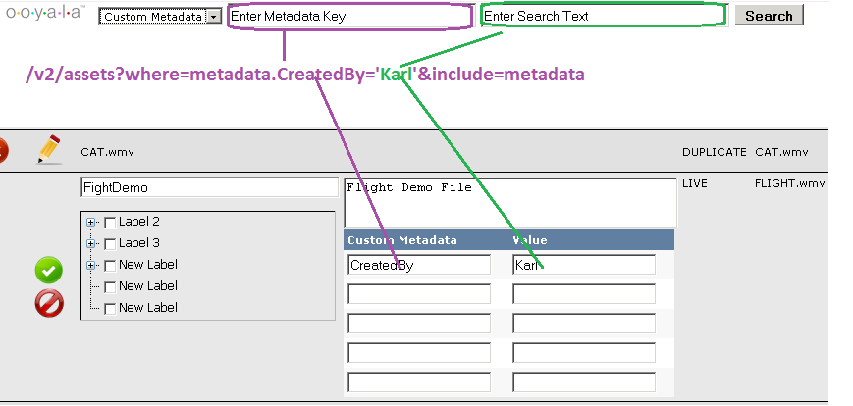
Media Library with thumbnail view

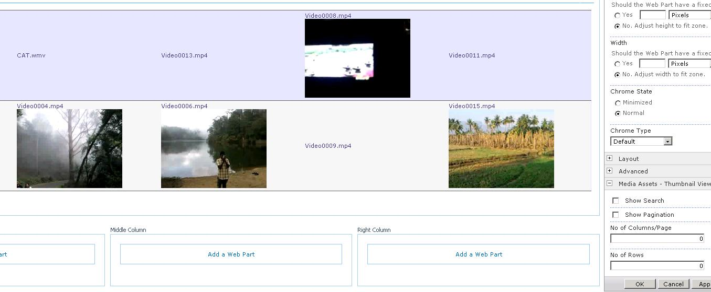

Show Media Library Thumbnail View with Pagination
- Login to SharePoint Application using SharePoint user.
- Click on Thumbnail View Link available in SharePoint Plug-In
- Click on Edit web part link to select Show Pagination
- Pagination appears on bottom of the Media Library Thumbnail View
- By default grid displays 8 column and 2 rows records per page, Page Size can be changed and it is configurable in Edit Mode.
- Click on Previous button to view the previous set of records.

Show Media Library Thumbnail View with Search facility
- Login to SharePoint Application using SharePoint user.
- Click on Thumbnail View Link available in SharePoint Plug-In
- Click on Edit web part link to select Show Search Option
- Search criteria appears on top of the media library thumbnail view
- Media Library facilitates with search criteria by Name, Description, Label, and Status and custom meta data.
- Enter the search criteria in textbox select one of the items in drop down list click on search button
- Search results will be displayed in thumbnail view.

Media Player
Select any Media Asset from the Asset List Dropdown or enter Media Asset’s Embed Code in the Textbox and Click Apply/OK. Selected asset will play in Default player. Here user can select their own Media Player from Player List in Edit Mode of the Media Player web part.

Media Player Settings
User facilitated to configure player properties, create custom players for your video/audio content. The default player will be used if no custom players created.

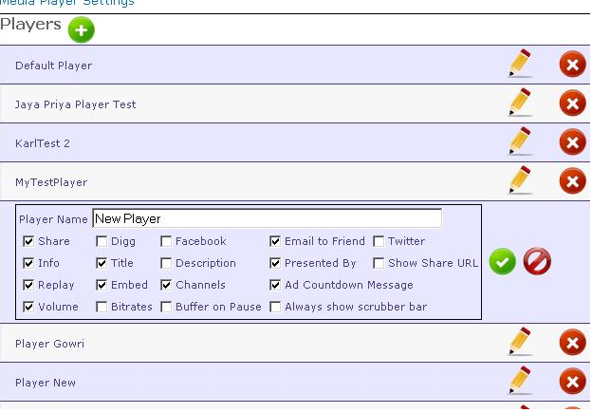

Creating New Player
User facilitated to create new player by clicking on New button and customize player properties. To create a player:
- Login to SharePoint Application using SharePoint user.
- Click on Media Player Settings Link available in SharePoint Plug-In
- Click on Edit web part link to select Allow Add New Player
- Plus icon appears on top of the media players list
- Click on plus icon to create new player
- Backlot creates a new player with the name “New Player”
- Click on Edit icon of “New player” to change its name or associate properties.
- See Edit Player to customize the player settings.

Edit Player
User facilitated to edit the look and feel and properties of a player at any time. To edit a player:
- Login to SharePoint Application using SharePoint user.
- Click on Media Player Settings Link available in SharePoint Plug-In
- Click on Edit web part link to select Allow Edit Player
- Edit icon appears on right of the media players
- Click on edit icon to edit player properties
- All player associated properties appears on the bottom of the player with checkboxes.
- Check/Uncheck required checkboxes
- Click on Tick icon and player properties will be saved into Backlot Application.

Delete Player
User facilitated to delete a player at any time. To delete a player:
- Login to SharePoint Application using SharePoint user
- Click on Media Player Settings Link available in SharePoint Plug-In
- Click on Edit web part link to select Allow Delete Player
- Delete icon appears on right of the media players
- Locate a player in the left pane and click its delete icon.
- You are prompted for confirmation and Click Yes.
The player will be deleted.

Media Upload From Local Computer

Upload Contents from Local Computer to Ooyala
- Login to SharePoint Application using SharePoint user
- Click on Upload From Local Computer Link available in SharePoint Plug-In
- On clicking “Browse” button, the plug-in will list out the assets available in Local Computer
- Provide standard metadata like “Title” and “Description”
- Click on the drop down list to select Post uploaded status like Pending Approval or Live
- On clicking Upload Icon, the plug-in will upload the asset along with “Name” and “Description” to Backlot Application

Associating an Asset with a Label
Labels are useful for organize video library, searching for videos.
Associate an asset with label:
- Login to SharePoint Application using SharePoint user
- Click on Upload From Local Computer Link available in SharePoint Plug-In
- Click on Edit web part link to select Allow Labels
- On clicking “Browse” button, the plug-in will list out the assets available in Local Computer
- User facilitated to include label either single or multiple while uploading asset, the selected checkbox text associates with asset.
- On clicking Upload Icon, the plug-in will upload the asset along with Labels to Backlot Application
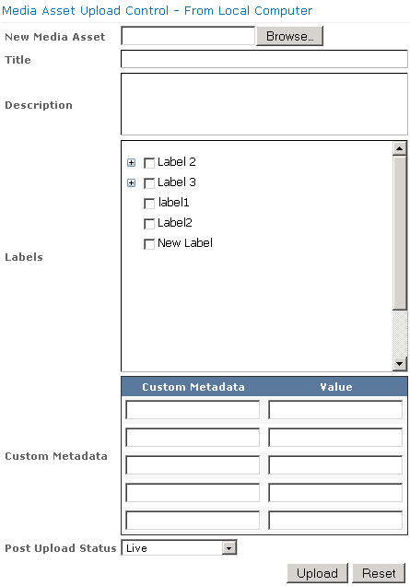

Associating an Asset with a custom Meta data
Custom metadata enables to add useful information to your assets. User can associate custom metadata with videos, Custom meta data useful for purpose of Organizing and categorizing content, Storing information about videos to display on pages on which they are embedded, Specifying information about how to display videos
- Login to SharePoint Application using SharePoint user
- Click on Upload From Local Computer Link available in SharePoint for Backlot Plug-In
- Click on Edit web part link to select Allow Custom Meta data
- On clicking “Browse” button, the plug-in will list out the assets available in Local Computer
- For each metadata entry, enter a Name and Value.
On clicking Upload Icon, the plug-in will upload the asset along with Custom Metadata to Backlot Application

Media Upload From Share Point Library

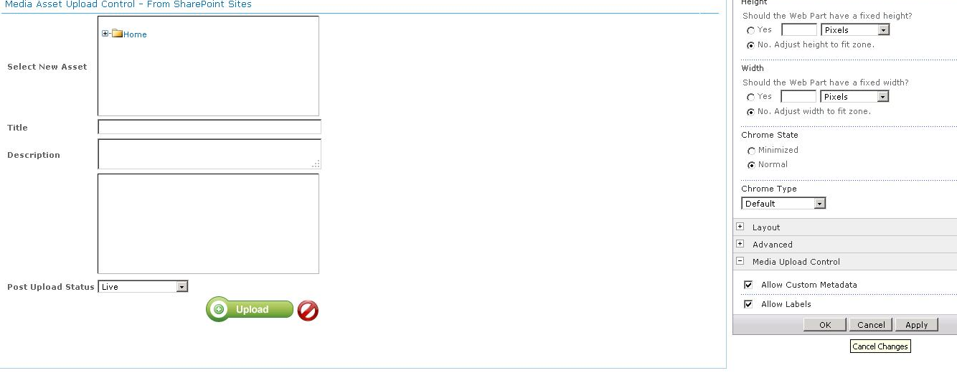

Upload Contents from share point library to Ooyala
- Login to SharePoint Application using SharePoint user
- Click on Media Upload From SharePoint Link available in SharePoint Plug-In
- Tree view structure list out the assets available in share point library
- Select the New asset from tree view structure of share point library to upload
- Provide “Title” and “Description” about the asset
- Click on the drop down list to select Post uploaded status
- On clicking “Upload” Icon, the plug-in will upload the asset along with “Name” and “Description” from share point library to Ooyala Backlot

Associating an Asset with a Label
Labels are useful for organize video library, searching for videos.
Associate an asset with label:
- Login to SharePoint Application using SharePoint user
- Click on Media Upload From SharePoint Link available in SharePoint Plug-In
- Click on Edit web part link to select Allow Labels
- Select the New asset from tree view structure of share point library to upload.
- User facilitated to include label either single or multiple while uploading asset, the selected checkbox text associates with asset.
- On clicking Upload Icon, the plug-in will upload the asset along with Labels to Backlot Application

Associating an Asset with a custom Meta data
Custom metadata enables to add useful information to your assets. User can associate custom metadata with videos, Custom meta data useful for purpose of Organizing and categorizing content, Storing information about videos to display on pages on which they are embedded, Specifying information about how to display videos
- Login to SharePoint Application using SharePoint user
- Click on Media Upload From SharePoint Link available in SharePoint Plug-In
- Click on Edit web part link to select Allow Labels
- Select the New asset from tree view structure of share point library to upload.
- For each metadata entry, enter a Name and Value.
- On clicking Upload Icon, the plug-in will upload the asset along with Labels to Backlot Application

